# ITP 499, Fall 2021

# Homework 7 20 points

**Problem**

Go to <https://math.mit.edu/ennui/> and explore this visual CNN modeler and training demo.

Instructions:

* Start with the Default template
* Set the source to be MNIST
* Add a second convolutional layer and a second Max Pooling layer
* Also add a Dropout layer
* Use this diagram as your guide.
* Then train the CNN with Adam optimizer and CrossEntropy as loss function. Epoch = 30.
* For other parameters it is your choice

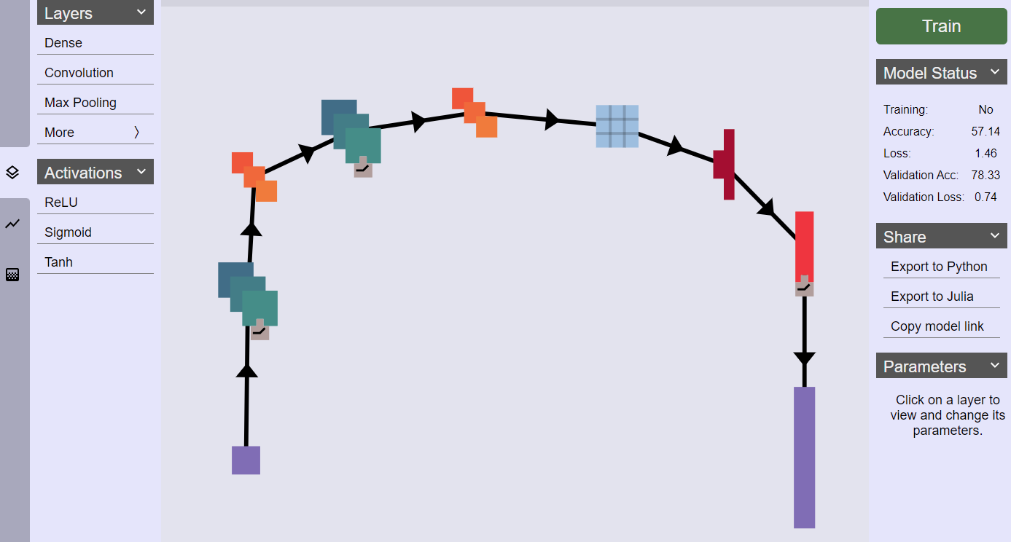

Then answer the following questions.

Insert screenshots to support each answer.

1. Display your CNN (2)

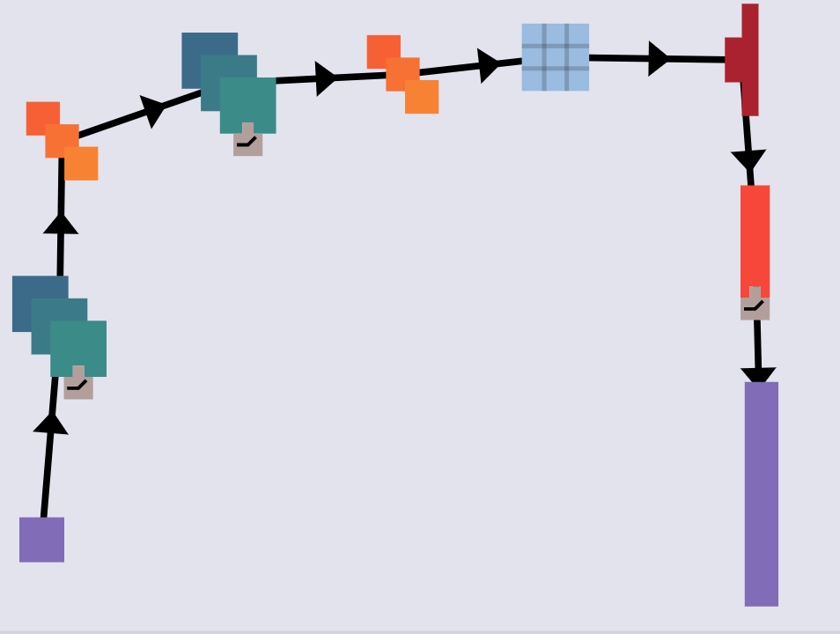

1. List the types of layers available to build CNN models in this web application. (2)

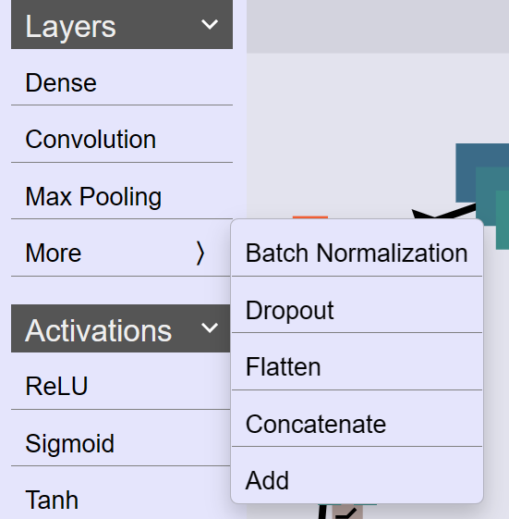

Dense, Convolution, Max Pooling, Batch Normalization, Dropout, Flatten, Concatenate, Add

1. List the activation functions available to build CNN models in this web application. (2)

ReLU, Sigmoid, Tanh

1. What is your model accuracy? Loss? Validation Accuracy? Validation Loss? (2)

|  |  |
| --- | --- |
| Accuracy | 71.43% |
| Loss | 1.04 |
| Validation Accuracy | 82.93% |
| Validation Loss | 0.62 |

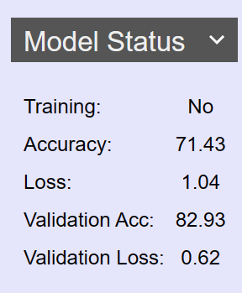

1. Display the Loss Curves and Accuracy Curves (2)

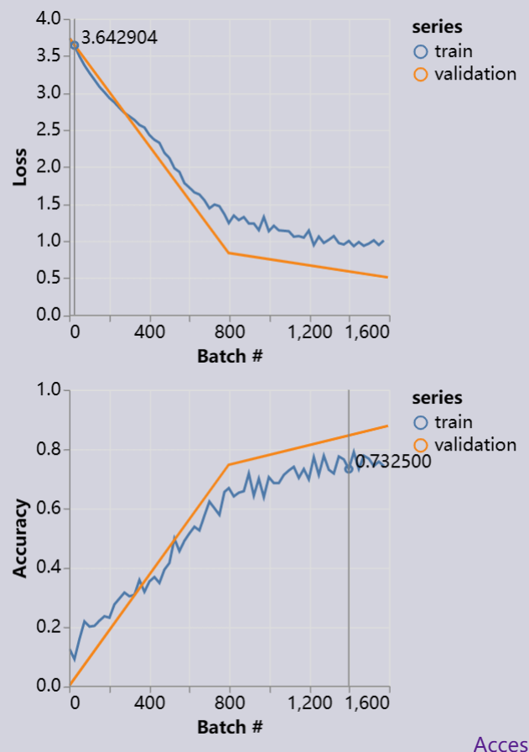

1. Display the confusion matrix (2)

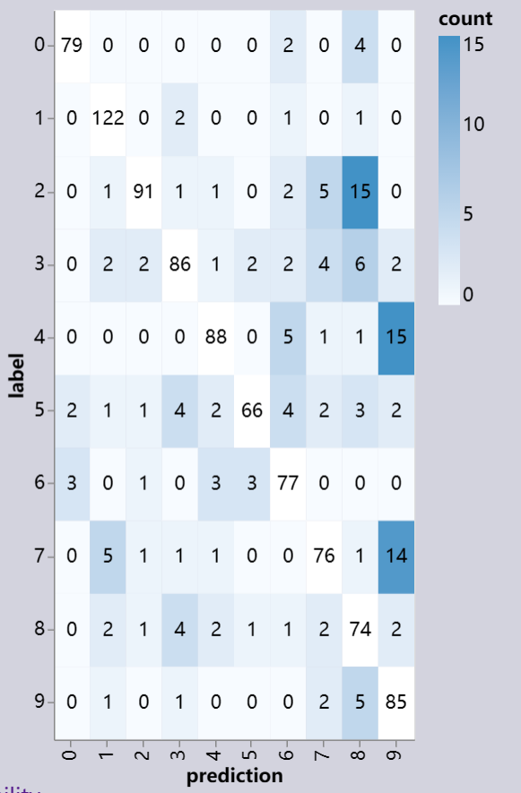

1. Display a few correct predictions (2)

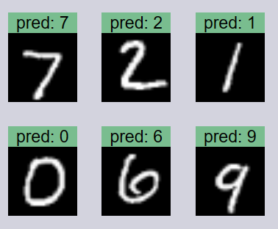

1. Display some incorrect predictions (2)

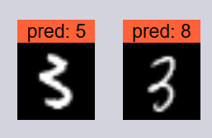

1. Export the model to Python. Then run the Python code. Display the test loss and test accuracy. (4)

